THE HABER-BOSCH PROCESS Name_______________

Nitrogen is in proteins and DNA and is an element vital for life. Every living organism must metabolise nitrogen to survive.

Nitrogen gas occupies 79% of the air we breathe, but is almost completely inert (unreactive) and cannot be absorbed by plants. In nature, only bacteria can convert nitrogen gas into soluble ionic compounds that can be absorbed and used by other living organisms.

1. What about the structure of nitrogen gas makes it so unreactive?

N₂ molecule has very strong triple bond holding two N atoms together
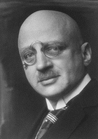
Chemical fertilizers provide an abundant source of nitrogen for plants. Up to the beginning of the 20th Century, nitrogen fertilizers were obtained by mining saltpetre (NaNO₃) from countries such as Chile, but supplies began to run out. In 1908 Fritz Haber discovered a chemical process to make ammonia gas (NH₃) from nitrogen and hydrogen that could be used to make artificial fertilizers. Carl Bosch commercialized the process in 1910. In 1918 Haber won the Nobel Prize in Chemistry for his discovery.

2. The process involves the reaction of hydrogen and nitrogen gas to produce ammonia gas. Write a balanced equation for the reaction:
FRITZ HABER ¹
1868-1934

N₂(g) + 3H₂(g) → 2NH₃(g)

The clever technology actually involves producing the N₂ and H₂ in the right proportions for the reaction. This is called Synthesis Gas. In Kwinana Western Australia, the company Wesfarmers CSBP is a major manufacturer of NH₃ and uses this process.
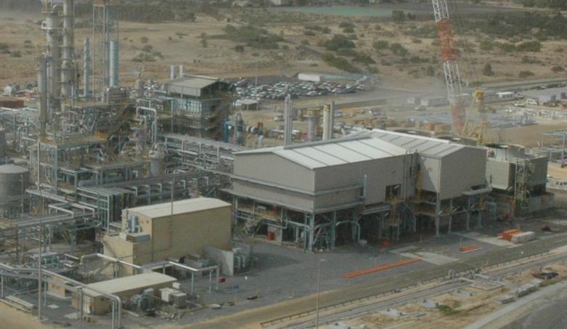

The raw materials used are natural gas, obtained from the North of WA and atmospheric air, which are the source of the hydrogen and nitrogen respectively.
CSBP AMMONIA PLANT

SYNTHESIS GAS PREPARATION

A. NATURAL GAS CLEANING:
The natural gas must firstly be “cleaned” of sulfur contaminants.

3 Why is this step necessary?

The sulfur “poisons” the catalyst and prevents it re-forming
The contaminating sulfur is converted into hydrogen sulfide that is then absorbed in a bed of zinc oxide, resulting in “clean” methane.
CH₃SH_{(g)} + H_{2g} → CH_{4(g)} + H₂S_{(g)}

H₂S_{(g)} + ZnO_{(s)} → ZnS_{(s)} + H₂O(g)

B. REFORMING to produce hydrogen gas:

Primary reforming involves the reaction of steam (H₂O) over a catalyst of NiO to produce carbon monoxide and hydrogen. The carbon monoxide then further reacts with steam to produce carbondioxide and hydrogen. Natural gas is burnt in the primary reformer and temperatures of 760ºC are achieved.

4. Write and balance the two equations for this process:

CH₄ + H₂O → CO + 3H₂
CO + H₂O → CO₂ + H₂

How many moles of hydrogen are produced from one mole of methane? FOUR

Why is it necessary to burn the natural gas in the primary reformer?

To provide the necessary activation energy for the reaction.

Secondary reforming occurs with air being added:

CH_{4(g)} + H₂O_{(g)} → CO_{(g)} + 3H_{2(g)}

2 H_{2(g)} + [O_{2(g)} + N_{2(g)}] → 2H₂O_{(g)} + N_{2(g)}

At this stage the ratio of N₂ to H₂ is 1:5

5. The oxygen is burnt in the reaction, raising the temperature to around 950ºC. What advantage is this for the process?

It provides activation energy for the reaction

C. SHIFT REACTIONS:

In the Shift Section, Here two “shifts”, one at a high temperature and one at a lower temperature, convert the CO to CO₂ using excess steam from the reforming section:

SHIFT 1 (400ºC): CO_{(g)} + H₂O_{(g)} → CO_{2(g)} + H_{2(g)}
Here the catalyst is an Fe, Cr and Cu mixture.

SHIFT 2 (200ºC): CO_{(g)} + H₂O_{(g)} → CO_{2(g)} + H_{2(g)}
Here the catalyst is an Zn, Al and Cu mixture.

6. What are catalysts and why are they important?

Catalysts are vital to improve reaction rate. They provide an alternative reaction path with lower activation energy. They are not consumed in the reaction.

D. REMOVAL OF CO₂ and CO:

At CSBP CO₂ is removed by absorbing it into a colourless liquid solvent called activated methyl-di-ethanolamine, CH₃N(C₂H₄OH)₂.

In the process of methanation, the final step is to convert the remaining CO (0.2%) and CO₂ (0.05%) into methane in the methanator:

CO_{2(g)} + 4H_{2(g)} → CH_{4(g)} + 2H₂O_{(g)}
7. Give reasons why this step is very important:

These gases are poisonous to the catalyst. The methane can be recycled saving the environment and cost.

8. The final mixture, the synthesis gas, has a ratio by volume of 1:3 N₂ to H₂. Why is this the best ratio to achieve?

This is the correct stoichiometric ratio for the reaction

AMMONIA SYNTHESIS:

To produce the ammonia, the synthesis gas is compressed to a pressure of 20MPa, heated to 500ºC and passed over catalyst beds of magnetite (iron oxide).

The ΔHº for the reaction is -92.4 kJ/mol.

9. Write the equilibrium constant expression the the reaction:

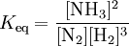

10. Explain using Le Chatelier’s principle, what is the effect on the equilibrium yield of NH₃ as the temperature is increased?

Since reaction is exothermic, reaction tends to reverse at high temps, so yield reduces.

11. What is the effect on the value of K as the reacting temperature is increased?

K is greatly reduced

12. Given your answers to questions 10 and 11, why are such apparently high reaction temperatures used?

A relatively high temperature is needed to ensure a reasonable rate of reaction. and the efficient working of the catalyst.

13. Why is the reaction conducted as such a high pressure?

There are less moles of gas produced as the reaction proceeds so pressure lowers, at high pressure equilibrium favours product

14. When the synthesis gas is passed over the catalyst beds, only 15% is converted into ammonia. How is this yield increased?

Keep passing reaction mixture over the beds ($ times gives 98% yield) and remove NH₃

15. How is the ammonia gas removed from the mixture of ammonia, nitrogen and hydrogen gases?

At higher pressures HN₃ liquefies easily (bp is –34ºC), so it can be drained off

16. In addition to the production of fertilizers, in what other ways is ammonia used?

Production of feedstock for manufacture of explosives, nitric acid and making sodium cyanide (for refining nickel). Used as a refrigerant, cleaning formulations and in the manufacture of rubbers, textiles and some pharmaceuticals.

17. List some of the physical and chemical properties of ammonia.

Colourless gas, pungent odour, less dense than air, very soluble in water.
Weak base: reacts with water to produce ammonium and hydroxide ions
Neutralises acids to form ammonium salts
Reacts with metal oxides and hydroxides to produce complex ions.

18. While the ready production of nitrogen fertilizers has sustained many millions of lives on the earth, Haber’s process also cost a few. Find out how the process cost many extra lives during World War 1.

Provided Germany with raw materials to make explosives, otherwise they would have run out of ammunition and the war would have finished two years earlier.

1. http://nobelprize.org/nobel_prizes/chemistry/laureates/1918/haber-bio.html

